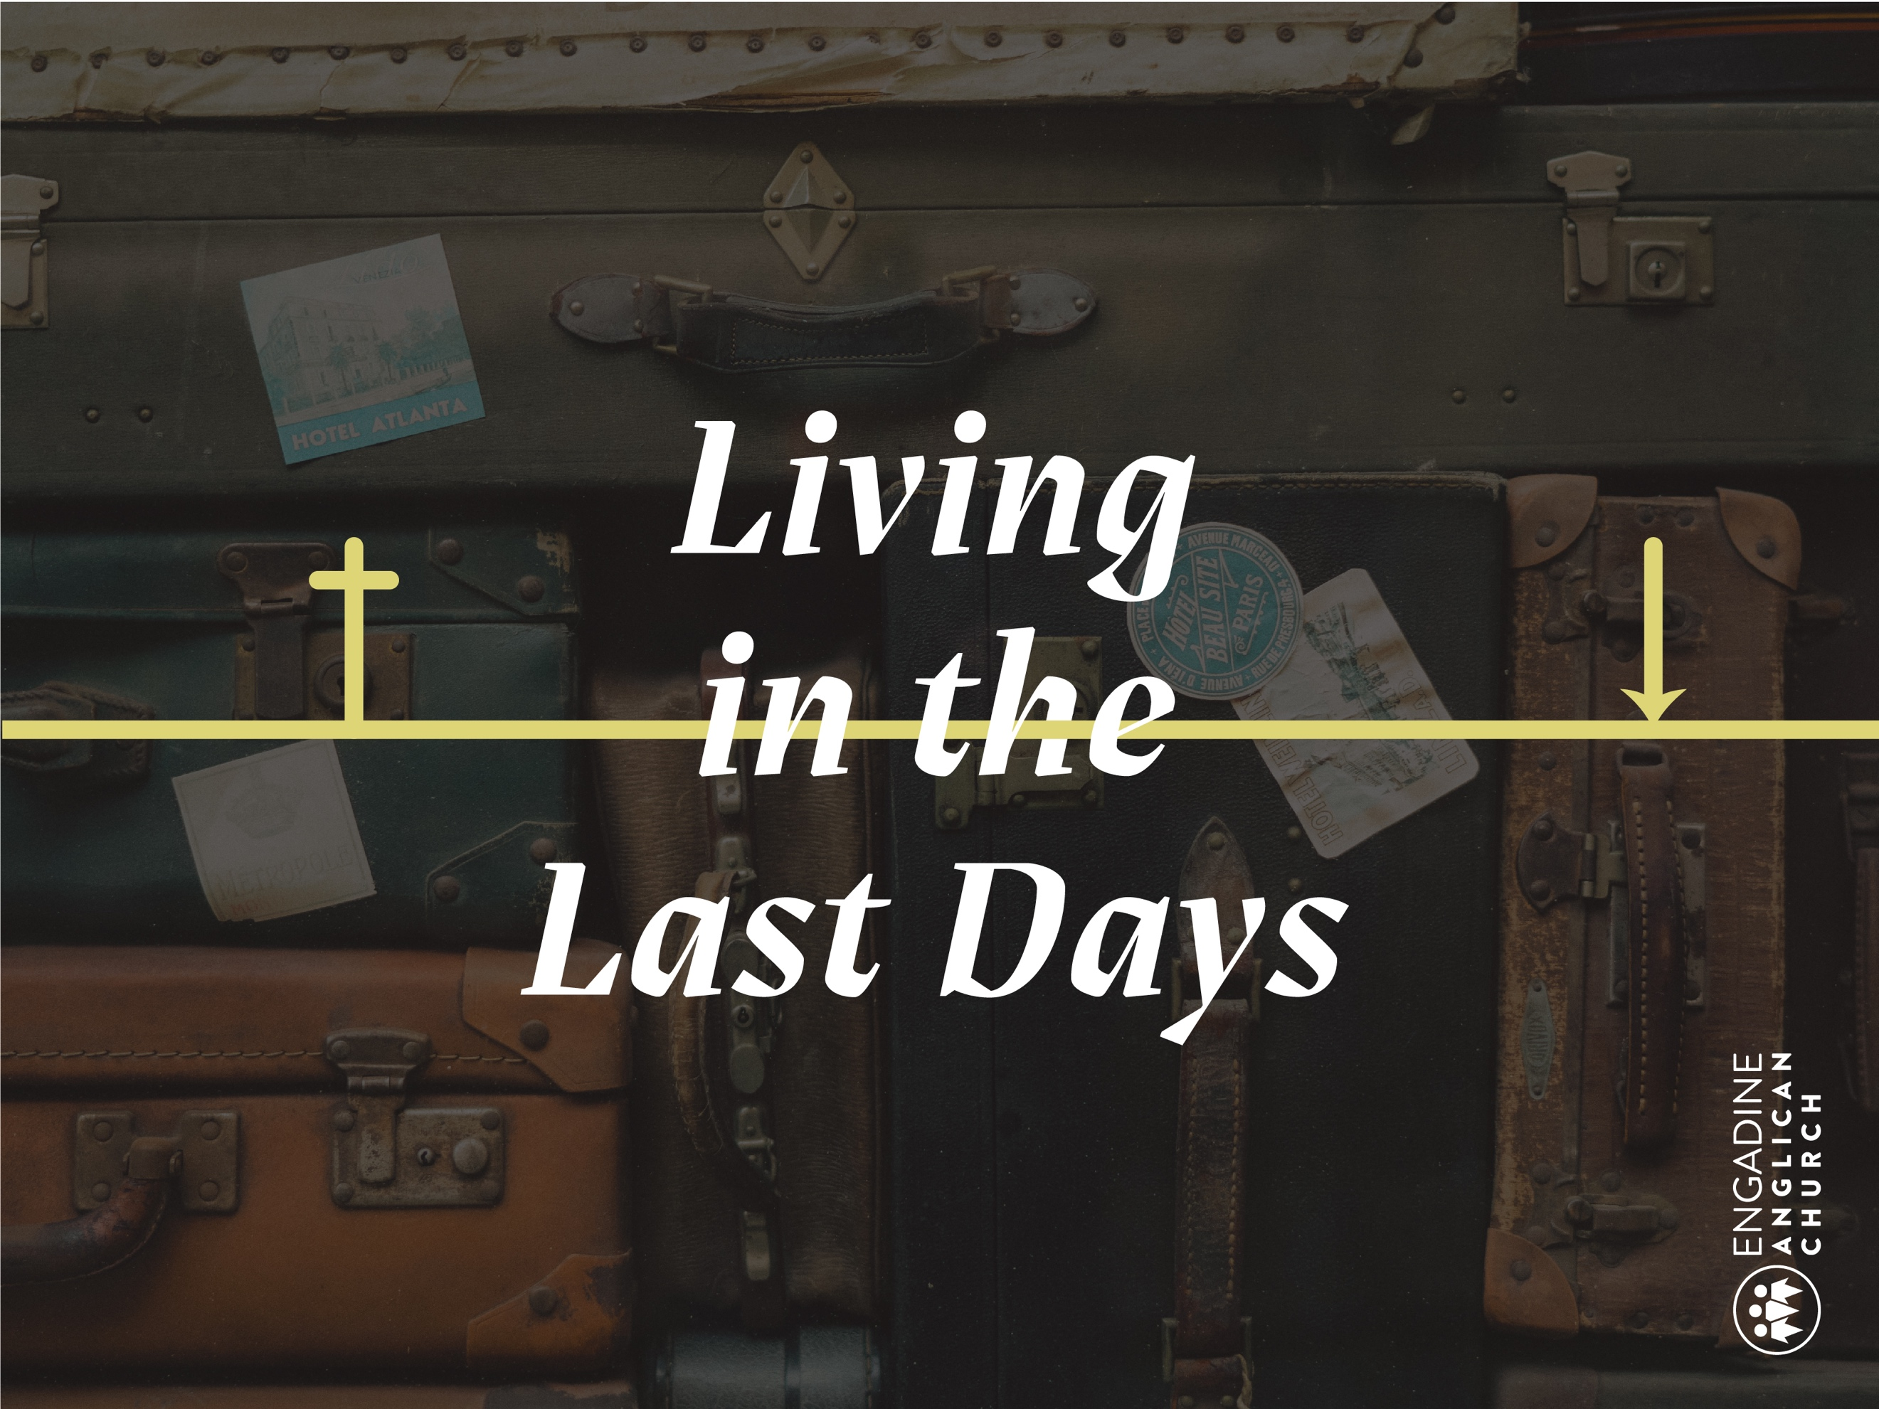

Growth Groups Studies
Term 3 2019 (Part 2)

Sermon Series
Living in the Last Days

For the 2nd half of this term we will explore a mini series on ‘Eschatology’: what the Bible teaches about the end of this world’s history, or the “last days”.

Normally at church, our main diet is “exegetical” - we carefully work through one book of the Bible, passage by passage. This is our main diet as God has written the Bible this way for us. However, once a year we also do a series on “systematic theology” – seeing what the whole Bible says about a certain theme. Instead of concentrating on 1 passage, we explore and summarise the connections between many passages. This then equips us to read any particular Bible passage with better context and understanding.

Sundays
1 Sept Beginning of the Last Days (Jesus’ 1st coming)
8 Sept End of the Last Days (Jesus’ 2nd coming)
15 Sept After the Last Days (Heaven & Hell)
22 Sept Family in the Last Days
29 Sept Church in the Last Days
6 Oct Sin & Holiness in the Last Days

The studies are based (with permission) on helpful articles by Matt Payne (Ingleburn Anglican) and Philip Jensen (2 Ways Ministries).
- stretchtheology.com/the-last-days-in-the-bible-eschatology-101/
- phillipjensen.com/resources/what-joy-in-hell/

Studies
Study 1 The Old Testament expectations of the Last Days
Study 2 The New Testament fulfilment of the Last Days
Study 3 After the Last Days (Heaven & Hell)
Study 4 Living in the Last Days (‘War’)
Memory Verse
1 Peter 2:11-12
Dear friends, I urge you, as foreigners and exiles, to abstain from sinful desires, which wage war against your soul. Live such good lives among the pagans that, though they accuse you of doing wrong, they may see your good deeds and glorify God on the day he visits us.

Memory Diagram
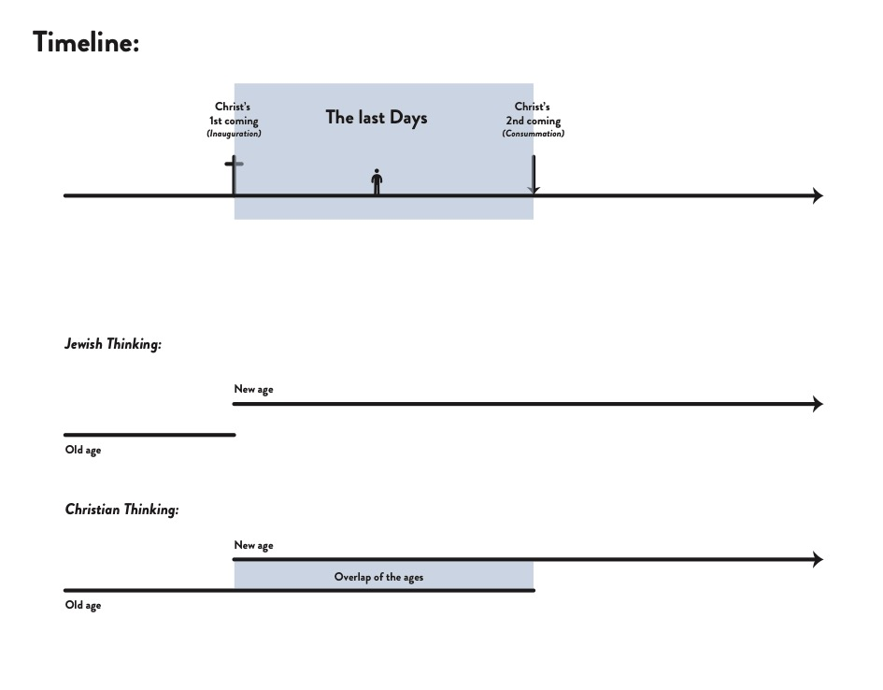
It’s so helpful to have a mental picture of how the Bible fits together. So help each other learn this diagram (or even the more detailed ones in the studies).
Study 1
The Old Testament expectations of the Last Days
This study explores the intriguing and detailed way that the Old Testament describes the coming “Last Days” (the future time when God would fulfil all his promises).
1. How would you define “history”?

Not all cultures believe in history. Most ancient cultures thought of time as circular, having neither beginning nor end. History is a cycle of alternating golden ages and dark ages. This seems intuitive: the seasons cycle around year by year always the same; kingdoms rise and kingdoms fall and kingdoms rise up again. There is no obvious reason to believe that history has some greater purpose or direction. Whether you watch the weather or a clock-face, time moves in circles, taking us back to where we have already been.
The Bible gives a very different view, one that shatters our human intuitions. God made the world with a purpose that will be achieved in the course of time. History itself will be ‘fulfilled’ when it comes under the rule of the Lord Jesus and finds universal perfection and harmony in him (Ephesians 1:10).
2. How does Australian society view the future?

Western culture’s philosophy of history grew out of Christianity. Today most people act like history is supposed to head somewhere largely because this biblical idea is embedded in our cultural past. Western culture once took the Bible very seriously. However, from the 17th century onwards, the development of scientific method combined with new anti-God philosophies led westerners to become so confident in our own abilities that we gradually reinvented the Christian view of history. We held onto the Christian idea that history is supposed to lead toward utopia, but removed Jesus from the picture. ‘Progress’ became a purely human project, and thus ‘utopia’ became within the grasp of humanity to achieve through our own wisdom and ingenuity. It’s a more sophisticated version of the Tower of Babel mindset. Whereas they built a tower upwards into heaven, humanity is now intent on building a tower of progress forwards into the future (Genesis 11:4).
The two world-wars of the 20th century shattered confidence in human ability to bring about utopia, but the old attitude appears to be regaining strength. Modern culture wars of ‘right’ versus ‘left’ represent competing philosophies of what makes for a good world. We all want a good world, but the level of passion that these debates excite shows an alarming underlying attitude: people act like they are fighting for nothing less than the salvation of society. Human utopia projects are always doomed to failure. The cultural battlegrounds will inevitably shift once again, but the Bible’s better hope will remain constant, as it always has.

3. Overall, what did the Old Testament say would happen in the future (“Last Days”)?
- Isaiah 2:2-4, 13:9

- Jeremiah 33:15-16

- Hosea 3:4-5

Theologians use the word eschatology (Greek: “last things”) to refer to what the Bible teaches about the end of history. Time isn’t just a topic in the Bible; it’s the framework for understanding the whole book. Throughout the Bible God makes promises that await fulfillment in the future. The prophets of the Old Testament repeatedly referred to the fulfillment of God’s promises as occurring in the “last days”, or “on that day”, or “in those days”, when God will arrive to decisively save, judge, and rule (e.g. Isaiah 2:2-4, 13:9; Jeremiah 33:15-16; Hosea 3:4-5). As soon as a prophet started talking about a ‘day’ or ‘days’ ahead he was talking about the time when God would fulfill his promises. The vague description of timing was deliberate. God’s timing is his own business; it is his people’s part to wait faithfully.
4. The Old Testament prophets promised that a lot of things would happen in the last days.
In summary, it looked something like this:
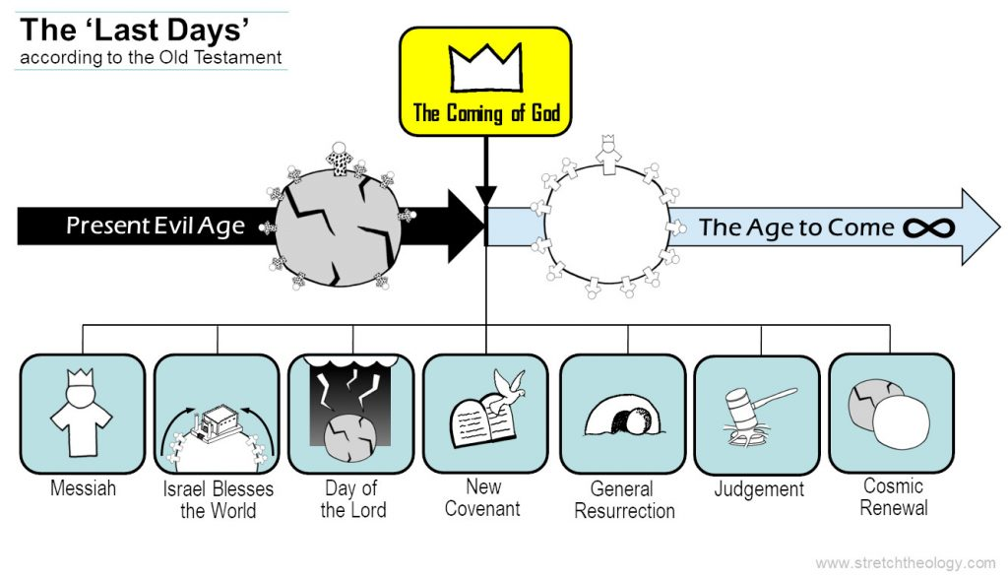
At some point in history, God would arrive to bring salvation and judgement to the world. He would bring an end to the present evil age of sin, injustice, and godlessness, and he would rule over all things unopposed in the Age to Come.
Whilst this basic idea of the “Last Days” is clear in the Old Testament, the specifics are more difficult to pin down. The Old Testament promises a large number of things that would happen in the last days, but it mostly isn’t clear how they fit together.
Read through the verses for each of these 7 key promises.
The great Messiah, the Son of David, would arrive to defeat their enemies and rule, bringing cosmic harmony (2 Samuel 7:12-16; Isaiah 11:1-16).

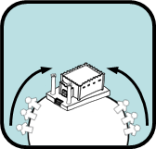
Israel was waiting for their Restoration, when their temple would become the center of the world to which the nations would gather (Isaiah 2:1-4; Jeremiah 3:17).

The Day of the Lord would come, which would be like the undoing of the fabric of creation itself in judgement (Isaiah 13:6-11; 24:1-3; Joel 2:31-32; Amos 5:18-20).

God would establish a New Covenant in which the law would be written on the hearts of his people (Jeremiah 31:31-34; Ezekiel 36:26-27; Joel 2:28-29).

The dead would be raised in a general Resurrection (Isaiah 26:19; Ezekiel 37:1-14; Daniel 12:2-3).

Creation would be renewed to harmony and ‘shalom’ (Isaiah 11:6-9; 65:17-19; Ezekiel 47:1-12).

There would be Judgement of all, living and dead (Daniel 12:2-3; Ezekiel 7:8; Daniel 7:9-14).

5. In your own words, try to summarise how the Old Testament views the future (“Last Days”)? If you were an Israelite, would you have looked forward to it?

Prayer points
- Insights from the Old Testament – Praise God for all the ‘clues’ in the OT - that God always had a merciful plan for the fallen world.

- Sunday gatherings: Engadine (9am, 10:45am, Night Church), Heathcote

- Growth groups - The personal discipleship engine room of our church

- Church staff team
- James & Di Warren, Josh, Ben, Emma – 9am & 1045am Engadine, Oversight
- Michael & Christina Dodd, Luke, Audrey, Ben – Night Church, Heathcote, MTS
- Ian & Megan Morrison, Jade, Timothy, Luke – Kids & Youth Ministry, Local Outreach
- Angus & Olivia Martin, Ted - 1st year Moore College, Youth leaders discipleship
- Dan & Shannon Bishop, Zeke, Jed, Abigail - Youth Ministry (2020+)
- Marg & Phil Chapman, Elise, Sophie, Dale - Overseeing office
- Michelle & Mal Mellows, Rachael, Bec, Daniel - Overseeing SRE & office

- Government
“I urge, then, first of all, that petitions, prayers, intercession and thanksgiving be made for all people— for kings and all those in authority, that we may live peaceful and quiet lives in all godliness and holiness. This is good, and pleases God our Savior, who wants all people to be saved and to come to a knowledge of the truth. (1 Tim 2:1-4)
- Commonwealth - Queen Elizabeth II (Australian head of state)
- Governor-General - His Excellency General the Honourable David Hurley
- Federal - Prime Minister Scott Morrison, Craig Kelly (MP House of Representatives - Hughes)
- NSW - Premier Gladys Berejiklian, Lee Evans (MP Legislative Assembly - Heathcote)
- Local - Councillor Carmelo Pesce (Mayor, Sutherland Shire Council)
Emergency services, judiciary, health sector, media
Study 2
The New Testament fulfilment of the Last Days
In this study, we see how the New Testament fulfils the whole Old Testament view of the future, in a very surprising way, with a “two-fold” coming of Jesus. We live between Jesus’ 2 comings in the “overlap of the Ages” or the “now but not yet” period.

1. How did Jesus mark the arrival of the “Last Days”?
- Mark 1:1-2, 1:10-11, 1:12-13, 1:14-15
- Mark 1:16-18
- Mark 1:21-34

The coming of Jesus marked the arrival of the last days. God the Son arrived to save and to judge by becoming one of us (Colossians 2:9; Matthew 1:23). Jesus’ message was that the Kingdom of God had arrived (Mark 1:15), meaning that the future “Age to Come” had come into the present. God’s rule would soon extend over all things through Jesus. Jesus demonstrated the presence of the “Age to Come” by his miracles of healing and provision, and his driving away demonic powers wherever they showed themselves (e.g. read Mark 1-5). The power of the Kingdom of God centers on Jesus.

2. What was confusing about the arrival of the “Last Days” in Jesus?
- What did John the Baptist expect would happen? (Matthew 3:7-12)

- How did Jesus explain himself (Matthew 11:2-6)

The coming of Jesus complicated Old Testament expectations considerably. People misunderstood the timing of Israel’s restoration (Acts 1:6) and of the resurrection (2 Timothy 2:18). Even John the Baptist was confused. When the Judgement of God didn’t arrive as John expected (Matthew 3:7-12), he sent his disciples to Jesus to inquire whether there had been some mistake. Jesus’ reply was to point to how he was dispensing promised end-time blessings to Israel (Matthew 11:2-6). Jesus was the expected Messiah and he would judge the world, but the judgement remained in the future (Matthew 25:31-46).
This confusion arose because Jesus divided the promised “Coming of God” into two parts.
- Jesus came first to win salvation, and will return to bring the salvation he has won to those who are waiting for him (Hebrews 9:27-28).
- The Day of Judgement has been delayed until that time so that people would have opportunity to turn to Christ (2 Peter 3:9). In the meantime, Jesus commissioned his followers to spread the news of salvation to all who need it (Matthew 28:18-20).
This two-fold coming of Jesus changes the picture to look something like this:
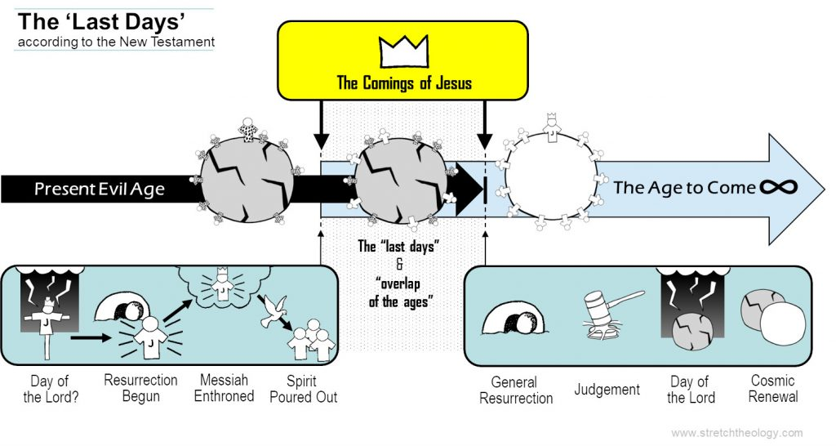
3. What has already started now, and what remains to happen?
Passage | Started already | Remains to happen
Romans 1:1-6
1 Corinthians 15:20-26

Ephesians 1:3-10

1 John 3:1-2

We presently live in the ‘last days’ promised in the Old Testament. The Resurrection Age has already begun with Jesus’ resurrection (Acts 4:2; 1 Corinthians 15:20-22). The eternal Messiah, the Son of David, is enthroned in heaven and will never lose his throne to death (Romans 1:2-4). Our traditional western calendar counts the number of years “A.D.”, Anno Domini, meaning “in the year of the Lord’s reign”. People of all nations are presently coming to Jesus, the true temple of God, to share in Israel’s salvation through hearing the gospel (Acts 11:18). Jesus has poured out his Holy Spirit onto all his people, writing his law on their hearts so they might obey him (Hebrews 10:15-16). All this shows that the Age to Come has already begun. These are the ‘last days’. Christians have begun living the eternal life of the Spirit now, even whilst we wait for it arrive in its fullness when Jesus returns (2 Corinthians 4:16; 5:2-4).
However, the present evil age (Gal 1:4) continues. People still sin and openly blaspheme the true and living God. Satan continues to tempt and to lead astray. Most pointedly, death still reigns. The present age will not end until death, the “last enemy”, is destroyed (1 Corinthians 15:26). For that we must wait for Jesus to return with judgement and justice, and to remake creation into an eternal dwelling fit for resurrection bodies.
The Old continues until death ends. The New began when Jesus rose. These two ages overlap in the present, pulling us in opposite directions. Hence, theologians also refer to this overlap of ages as the ‘eschatological tension’.

4. In your own words, explain the “overlap of the ages”. What is it like to live in this time?
Note: Another name is the “Now but not yet” period.

Prayer points
- Insights from the New Testament – Praise God that the “Last Days” has already arrived with Jesus. Pray we would understand how to live godly lives in the “overlap of the ages”.

- Anchor Youth (Friday nights; Sunday mornings Juniors; Sunday afternoon Seniors)

- Schools
- SRE Primary Schools (Engadine, Engadine West, Marton, Heathcote, Heathcote East, Yarrawarra, Waterfall) and SRE High Schools (Engadine & Heathcote); Michelle Mellows overseeing
- Lunchtime Christian groups (Engadine High) Shire Christian School)
- Generate (oversees paid chaplains & Scripture teachers)
- Connection with Bosco students

- HSC students & their families
Abby Begg, Bonnie Stonestreet, Casey Raudaschl, Charlie Taylor, Courtney Ahmet, Emma Warren, Holly Vanderjagt, Isabella Fanous, Jasmine Cairns, Jasmine Graham, Kayla Munckton, Katelyn Godi, Mikhala Thomas, Olivia Abbot, Rebecca Hall, Sarah Goode, Sarah Rathsam, Teagan Herron, Zahnri Bredell
Aidan Selcraig, Ben Twist, Eli Merritt, Jesse Smith, Kieran Griffiths, Michael Thompson, Oliver White, Patrick Murray

- Slovenia - Kingsley & Veronica Box, Zac, Sam, Tim, Sophia; returning to Australia late 2020

Study 3
After the Last Days (Heaven & Hell)
In this study, we reflect on the Bible’s teaching about what comes after the Last Days, the wonderful and terrible reality of heaven and hell.
- How does public media tend to portray heaven and hell? Which do you personally think more about?

Hell is such a horrible concept that we recoil from even considering it. Denying its existence can even be called a godly heresy. Godly – in that God does not enjoy the death of a sinner and nor should we (Ezekiel 18:23,32; 33:11, 1 Timothy 2:4, 2 Peter 3:9); but – a heresy none the less because the scriptures teach the reality of judgement and hell (Matthew 7:13, 21-23; 10:28). Our Lord Jesus himself used hell in his preaching, so we must not – and cannot – leave it out of our declaration of the whole counsel of God.
Hell is a horrible topic but we must not avoid thinking about it or preaching it, for it is the basis of seeing not only the ultimate justice of God but more importantly the greatness of our God’s compassion and saving work in Jesus.

- What does the Bible teach about hell?
- Isaiah 66:24

- Matthew 5:22,29, 10:28, 18:8-9, 25:31,41

- Mark 9:43-48, Luke 12:4-5

- James 3:6

- Revelation 14:9-11, 20:10

The Bible itself spends very little time describing or even mentioning hell. The word only occurs 12 times in the Bible, all in the New Testament, all but once on the lips of Jesus. Based on usage of the word ‘hell’, there is only one hell fire preacher in the Bible – and that is our Lord Jesus Christ.

The word itself referred to the valley of the sons of Hinnom, close to and outside Jerusalem. The valley had been used for human sacrifices to Molech but was intentionally ‘defiled’ in Josiah’s reforms (2 Kings 23:10, 2 Chronicles 28:3, 33:6). The prophets (Isaiah 30:31-33, Jeremiah 7:31, 19:5-6, 32:35) spoke of it as the valley of slaughter and of its fire and vermin as the final end place and destruction of the wicked.
The descriptions of hell are usually minimal but involve fire, corpses and vermin (Isaiah 66: 24, Mark 9:43, 48, Matthew 18:8 James 3:6). Other parts of the New Testament speak of the final state of judgement in terms of outer darkness, weeping and gnashing teeth, destruction, and second death. However, eternal fire is an image of God’s prepared punishment for the devil and his angels, to which sinful humans can be cast (Matthew 25:41, Revelation 14:10, 20:10).
While the word ‘hell and any descriptions of it are used sparingly in the Bible, retributive punishment is widely taught and illustrated. Such punishment is not limited to this world and lifetime only; for both judgement after death and life after death are clearly taught in scripture. (Isaiah 66:22-24, Hebrews 9:26-28). Indeed the very concept of “the resurrection” is one of judgement as well as eternal life beyond the grave (Matthew 10:28, Luke 14:14, John 5:28-29, Acts 17:31). Both this life and judgement are talked of as ‘eternal’ (Matthew 25:46). The permanence of this judgement is emphasized in Jesus’ parable (Luke 16:19-31), as well as Paul’s language of “eternal destruction, away from the presence of the Lord and from the glory of his might” (2 Thessalonians 1:9).
Whatever we do or do not know about the details of hell, it is clear from Jesus’ teaching that it is so terrible and terrifying that we should do all in our power to avoid it.

- How does God feel about hell?

- Amos 7:1-6

- Hosea 11:8-9

- John 3:16

- Romans 2:4-5

- 1 Timothy 2:3-6

- 2 Peter 3:9-10

Our hatred of hell is but a pale reflection of God’s detestation of its terrors.
It is God’s compassionate desire that none should perish, which moved him to give his only on that we should not perish at all but have eternal life (John 3:16); and it is because of his Son’s similar compassionate desire that Christ Jesus gave himself as a ransom for all (1 Timothy 2:4-6).

More reading: Is it true that “God doesn’t want to send anyone to hell”?
thegospelcoalition.org/article/hell-more-choice/

- What does the Bible teach about heaven?
- Isaiah 25:6-12, 65:17-25; Daniel 12:1-4

- Matthew 6:19-21

- Luke 13:32-34

- John 14:1-4

- Phil 3:20-21

- Hebrews 11:8-10, 13-16, 13:14

- Revelation 5:9-14, 7:9-17, 21:1-7, 22-27, 22:1-5

Note: When a Christian dies before Christ’s 2nd coming, they are with the Lord (Philippians 1:19 – 24). They are in Christ’s presence better than we are in life, but not yet part of the physical New Creation until the restoration of all things when there will be a new heaven and a new earth.
phillipjensen.com/resources/ministry-training-paper-what-happens-when-we-die/

Prayer points
- Insights about what comes after the Last Days – Praise God for the sure hope of heaven, and pray for sober reflection of the reality of hell, especially for many in our families and most of our neighbours in 2233.

- Kid’s Ministry
For all those who dedicate themselves to discipling our youngest members, both in weekly leadership and on rosters.
- Primary: Sunday Kid Churches (Engadine 9 & 1045, Heathcote), Friday Kids Plus (Engadine & Heathcote), Kids Hope, Tuesday GFS (girls), Thursday Gorillas (boys)
- Preschool: Sundays, Thursday Playtime, Friday Mini-music

- Pastoral Care
- For every member to watch their life and doctrine closely (1 Tim 4:16), and to be diligent in godliness, so that everyone may see their progress (1 Tim 4:15).
- Awareness and care of our church family’s needs, especially through our Growth Groups
- For those with new or chronic illness, addictions, relationship & financial difficulties, prodigal children, aging parents, or other hardship

- Dubai – Karen

Study 4
Living in the Last Days (‘War’)
In this study, we reflect on our experience of living in the Last Days, with the daily tension of belonging to the Age To Come, while living in this present Evil Age. This makes sense of the ‘war’ we feel, both outside us (world, Devil) and inside us (flesh).
We currently live in the “last days“: the time between Jesus’ resurrection and his return. In this “overlap of the ages” the exalted Lord Jesus tolerates the continued existence of sin and death in order to give people the opportunity to hear the gospel, repent, and be saved (2 Peter 3:9). The Age to Come and the Age of Evil will continue to co-exist until Jesus returns.
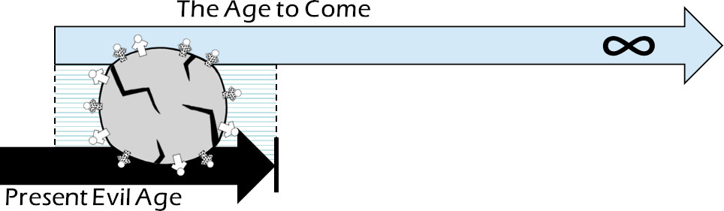
Another way of describing our era is as two realms in conflict. The resurrection of Jesus brought a new realm into existence, the Kingdom of God. Jesus’ death for sin made a way for sinners to become citizens of that kingdom. However, everyone who belongs to Jesus’ kingdom now lives in enemy territory. Jesus is the exalted Lord of all, but Satan, sin, and death continue to flourish in the meantime. The old order is at war against God’s kingdom and its citizens.
This study highlights some of the main ways that the Bible describes these two completely opposite realms and their conflict with one another. These differences are at the heart of the Christian identity and way of life.
“The classic summary of the enemies of the Christian life consists of three factors: the world, the flesh, and the Devil.”
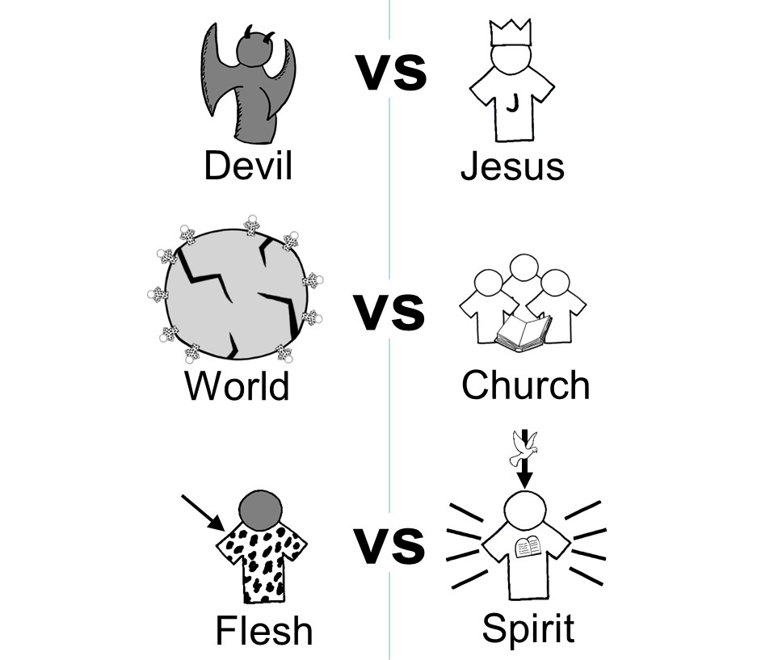

1. How do we experience war with the Devil?

- 2 Corinthians 4:4

- Ephesians 2:1-2

Whilst Jesus is Lord of all, and acknowledged as such by his people, Satan continues to ‘rule’ the way people live in the world.

2. How do we experience war with the world?

- 2 Timothy 3:12

- James 4:4

Whilst Jesus’ church gathers together and serves Jesus together, the world will persecute it and offer an alternate, sinful way of life and faith.

3. How do we experience war within our flesh?

- 1 John 1:8, 2:1-2

- Romans 6:14-23

- Galatians 5:16-26

Whilst Christians have the Spirit of God now, we still battle against the flesh.
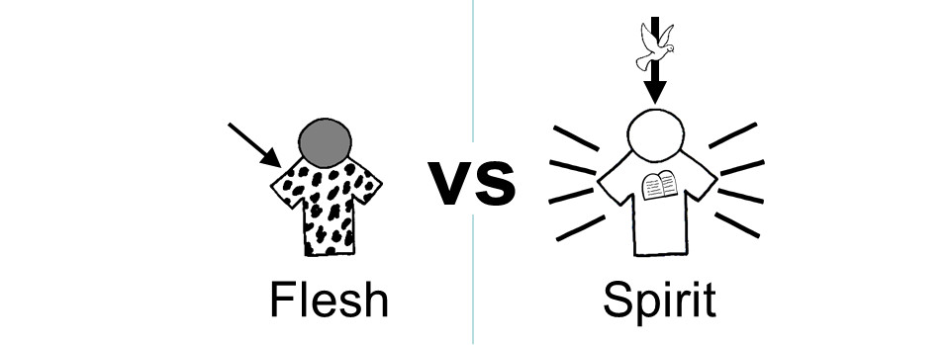
We are not yet physically resurrected. We are still our old ‘fleshly’ selves, and are therefore weak in the face of temptation and prone to sin. However the Holy Spirit is at work inwardly renewing us to obey God. The battle between Christ’s kingdom and our old fleshly slavery runs through the middle of every Christian. The Christian life is a battle between our fleshly nature and the Spirit’s work of inwardly renewing us.

In practice this means that whilst Christians will continue to struggle with sin (1 John 1:8, 2:1-2), God’s Spirit will bring about an observably new way of life in us. The life of the flesh is slavery to passions: being helplessly yanked around by our bodily urges and desires (Romans 6:14-23; Galatians 5:19-26). The Holy Spirit works in believers against this power of the flesh, bringing about conformity to God’s way of life, as we submit to God’s word.
How has God been at work in your life?
4. How are believers different to unbelievers?
- Romans 6:16-18; Galatians 5:1

- 1 John 3:4-10; 1:8

- 1 John 2:9-10; 3:13, 15; John 13:35

- 1 John 1:7; 2:9-11

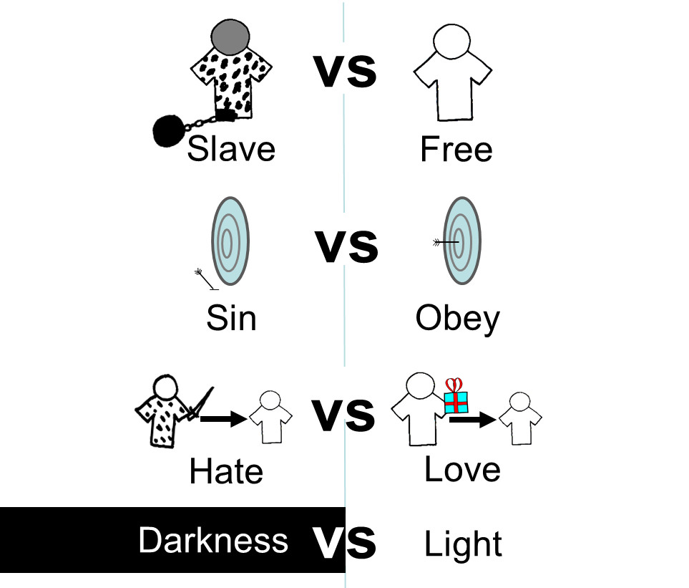
The Bible describes the differences between Christians and unbelievers. For example:

- Unbelievers are enslaved to their passions and blind to God’s ways. Christians are freed to live God’s way by the Spirit (Romans 6:16-18; Galatians 5:1).
- Unbelievers are marked by their sinfulness. Christians obey God imperfectly, but truly obey him nonetheless (1 John 3:4-10; 1:8).
- Unbelievers act in hatred toward others. The most fundamental mark of Christians is love for one another (1 John 2:9-10; 3:13, 15; John 13:35).
- In sum, we can say that unbelievers live in darkness whereas Christians live in the light (1 John 1:7; 2:9-11).
5. How are you currently experiencing the war (tension) of living in the “Last Days”?

Prayer points
- Insights about the tension of living in the Last Days – Pray for God’s Spirit to change our hearts as we humbly submit to his Word, helping us to say no to the flesh.

- Seniors Ministry
Praise God for the many godly older saints in our church family who model daily, costly obedience to Jesus. Pray for our seniors to retire and age well, continuing to serve Jesus with each new stage of life.
- As parents, grand-parents, aunts, uncles (biologically and spiritually)
- Ministry in Aged Care Facilities (John Paul Village, Moran, Garrawarra)
- Kids Hope mentoring
- Prime Time

- Families
- For those married: Husbands and wives (newly and oldly married) to remain faithful to each other, and to grow in love with Christ at the centre
- For those separated (publically or privately) – for trust in God, deep forgiveness, and healing of relationships; for all children involved; for great support for all involved
- For family devotions to be a regular part of home life
- For those with new or chronic illness, addictions, relationship & financial difficulties, prodigal children, aging parents, or other hardship

- Jordan - Mal & Charissa Forrest, & Aidan, Sasha, Toby

- Darwin - Wayne Oldfield & Mandy Jones - Nungalinya College

