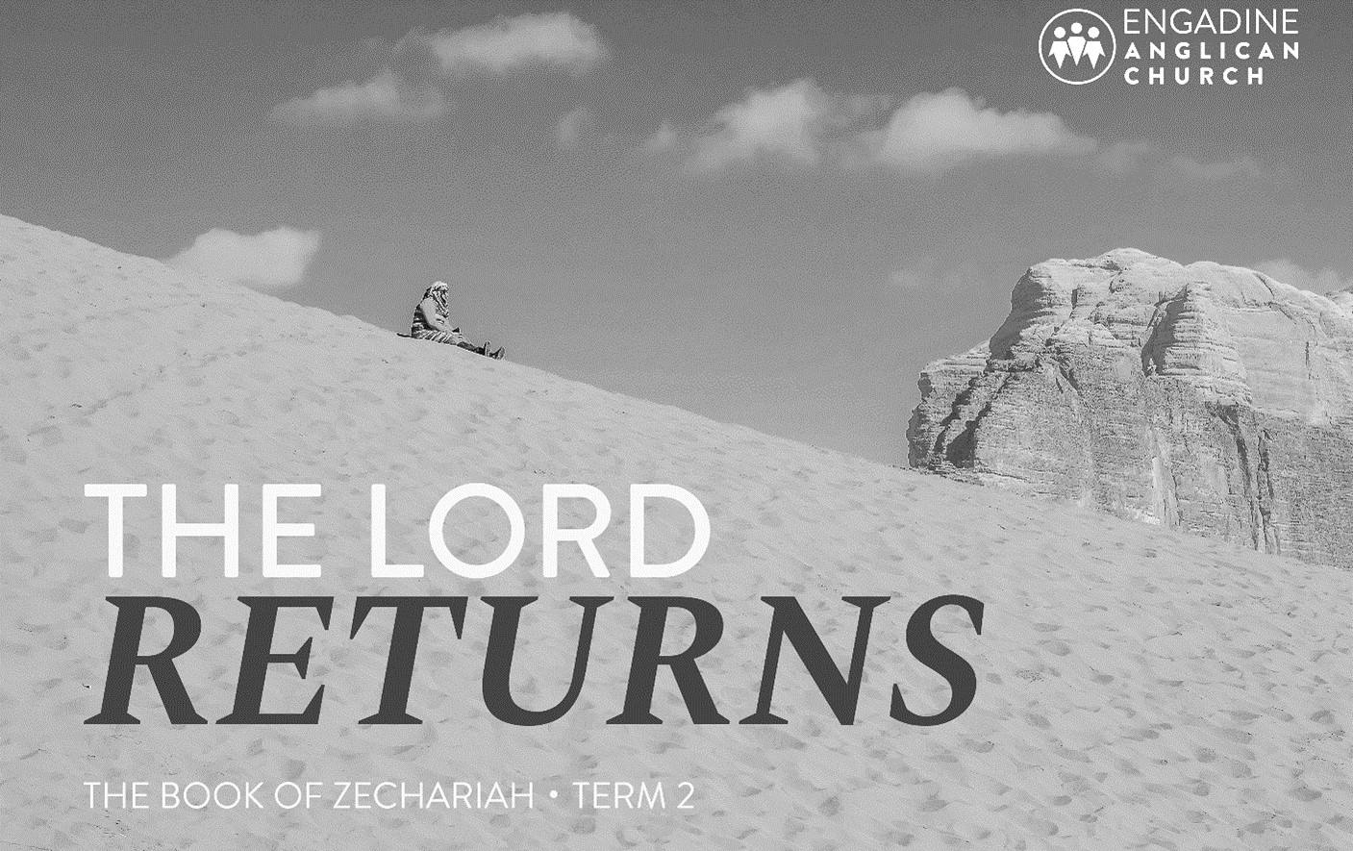
2024 TERM 2 – ZECHARIAH

Table of Contents
Introduction: Zechariah Studies 2
Study 1 Zech 1:1-6 Waiting for God to return. 5
Study 2 Zech 1:7 – 2:13 Waiting for God to dwell. 8
Study 3 Zech 3 - 4 Waiting for a functioning Temple. 11
Study 4 Zech 5:1 – 6:8 Waiting for sin’s removal. 14
Study 5 Zech 6:9 - 15 Waiting for a Davidic King. 17
Study 6 Zech 7 - 8 Ritual or Relationship? 20
Study 7 Zech 9 Return of the King. 24
Study 8 Zech 10 - 11 Rejected shepherds, redeemed people. 27
Study 9 Zech 12 - 14 Ruling King: Coming Day of the Lord 31
Supporting Notes. 35
Resources 37

Introduction: Zechariah Studies

Approach
These studies explore the main themes of the book as they are developed and have an emphasis on reading chunks and considering the context for the original hearers. Having appreciated that message in context we can then consider how it relates to us today post Jesus’ death and resurrection.
One difficulty faced in studying the Old Testament is the lack of familiarity we have with names, places, and the historical context. Each study has a brief introduction to help set the scene. The pre-reading aims to help give context and/or background to the passage being studied as well as reducing the amount of time required for the studies. Another challenge is the volume of material to cover. Summary sections provide an overview of parts of the book that are skipped to help with continuity.
A question followed by a star in superscript (*) indicates that the supporting notes at the back have more information.

Quick Facts
Author: Zechariah
Message: Call to trust God and his word, and to rebuild the temple in expectation of God’s return. In the future, God’s king will be installed, sin and idolatry will be removed, and the nations will be included.
Timing: Approx: 520 BC
Genre: Mix of Apocalyptic Visions and Prophecy

Outline

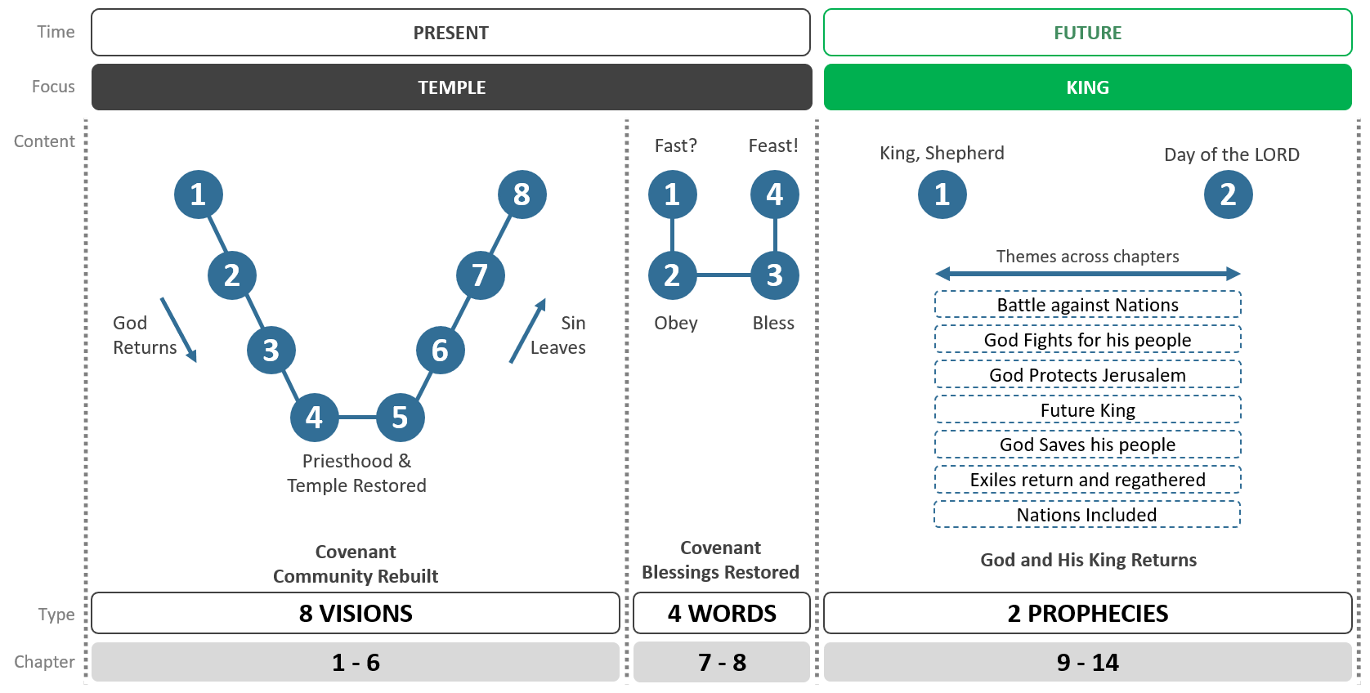

Timeline

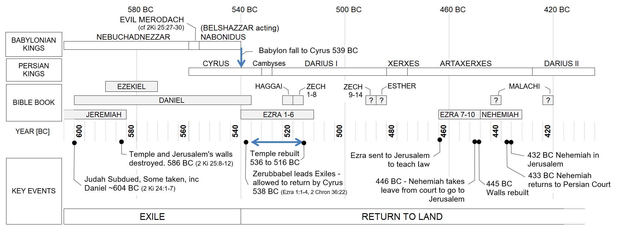

Study 1 Zech 1:1-6 Waiting for God to return.

Introduction
Zech 1:1 dates the book at 520 BC. Some of Israel has returned to the land but they are still ruled by a foreign king. It has been nearly 70 years since they were exiled for disobedience to the Mosaic Covenant (Deut 28:15, 36-37).
Zech 1:1-6 Return to the Lord.

Discuss
Why do you trust in God’s promises?

Investigate

Read Jer 25:1-14
- What was Jeremiah’s message v1-6? How was it received?
- What is God’s judgement? v7-11?
- What hope is held out in v12?
King Nebuchadnezzar does indeed come and attack Judah, they are exiled in the year 589 BC (2Ki 24:1-17) and the temple destroyed later in 586 BC (2Ki 24:18-25:12). In 539 BC Cyrus the Persian King defeats the Babylonians.

Read Ezra 1:1-4
- It is the year 539BC and v1 references Jeremiah, indicating we are at an important point in history. What does Cyrus proclaim?
The book of Ezra records what happens as the people return; they face opposition and hardship. In Ezra 4:24 we learn that the temple rebuilding stops. Some 20 years later, Darius is the ruling Persian king, when Haggai starts preaching.

Read Hag 1:1-11
- It is now 520 BC, what is his message to the returnees?
Zechariah’s message now comes a couple of months after Haggai (Hag 1:1 cf Zech 1:1)

Read Zech 1:1-6
- What is Zechariah calling the people to do?
- There are three questions in v5-6. What is the goal of these questions?
- God promises to return, what expectations would Zechariah’s audience have?

Reflection
Jeremiah prophesied that after 70 years of exile, Israel would be restored. It has been nearly 70 years, they are in the land, but not experiencing God’s blessing or presence. Zechariah’s message: they must not be like their forefathers, they must be obedient to the covenant, repent and turn from their evil ways to follow God. Today, like Zechariah’s contemporaries, we are told to learn from history and to be careful to heed its lessons (1 Cor 10:11-12).

- How are we to respond to God today?
- Mark 1:14-15

- 1 Thess 1:9-10

- Do you believe God’s word will achieve its purposes in the future?

Study 2 Zech 1:7 – 2:13 Waiting for God to dwell.

Introduction
It is approximately 20 years after the Israelite returnees had left Babylon and entered the land: life was hard, the temple rebuilding had stopped (Ezra 4:24) and God’s blessing was not evident. The 70 year period of the exile (God’s judgement for continuing disobedience) was nearing completion, but could they see that becoming a reality? Would they continue to trust God’s promises? In this context, Zechariah receives 8 visions. The first 3 relate to God’s return.
Zech 1:7-17 Vision 1: Man among Myrtle trees.
Zech 1:18-20 Vision 2: Four Horns and Craftsmen.
Zech 2:1-13 Vision 3: Man with measuring line.

Pre-reading
Exodus 14:19-25
Jeremiah 29:10-14

Discuss
What helps you to persevere in the Christian life?

Investigate

Read Zech 1:7-17
- What is the report given in v11 by the horses?
- How does the Angel of the Lord respond to this report (v12-15)? How does God respond?

- What does God promise (v16-17)? What impact might these have had on the original hearers?

Read Zech 1:18-20
- What historical events does v19 refer to?* (See pre-reading)
- How might the craftsmen coming terrify the nations? (Consider v15-16 and the rebuilding of the temple. Also: Hag 2:20-23 a prophecy given a couple of months prior to this vision)

Read Zech 2:1-13
- What is significant about the city without walls? v5.
- Why is it imperative that people flee Babylon? v6-7
- God is coming, what do we learn about that day? v10-13

Reflection
The three visions point to a reversal of the exile: God returns in mercy and will dwell with his people; the temple rebuilt; Israel regathered and the nations joining in, a time of gladness and prosperity. Israel was expecting the temple rebuilding to usher in a new age. The temple was rebuilt four years later, but God’s glory did not return at that time: the fullness of Zechariah’s visions was not fulfilled in their lifetime.

- Israel was looking towards the rebuilding of the temple, yet in the New Testament we learn God’s plans are bigger than a physical building. What does the New Testament say about Jesus?
- John 1:14

- Heb 1:3

We face a similar situation to Zechariah’s audience, we have God’s promises, yet we wait for them to be ultimately fulfilled - we look forward to a future day when Jesus will return. (1 Thess 1:10).
The Gospel is a message of comfort for God’s people, but of judgement for his enemies. Christians today should not be seduced and look for rest and ease in the world rather than Jesus’ kingdom. Revelation 18:4 calls us to come out of Babylon – the personification of all who oppose God, for it faces judgement. Revelation 21 describes the ultimate fulfilment of God’s promise to dwell with us.

Read Rev 21:1-4 & 22-24
- How is this an encouragement to you?

Study 3 Zech 3 - 4 Waiting for a functioning Temple.

Introduction
The first three visions focus on the reversing of the exile, the next two focus on the temple in readiness for the return of God. Joshua was the high priest and Zerubbabel* the governor, but they faced sin and opposition, do they have the strength to persevere?
Zech 3:1-10 Vision 4: Joshua’s sin removed.
Zech 4:1-14 Vision 5: Zerubbabel will rebuild the temple.

Discuss
How does God achieve his purposes?

Pre-reading
Leviticus 16:29-34
Isaiah 11:1-11
Jeremiah 23:5-8

Investigate

Read Zech 3:1-10
- The high priest had a special role – only he could perform the Day of Atonement ceremony where Israel’s sin is forgiven. In Lev 21:10-12 what do we learn about this role?
- Given the first question, how could the events in the vision (v1-7) relate to the rebuilding of the temple?

- Joshua and associates are a symbol of God’s servant, the Branch. What will God do in the future? V8-10

If you have time
- From the Pre-reading what do we learn about the Branch, what expectation is now set? (Compare v8-10)
- Jer 23:5-8

- Is 11:1-11

The Old Testament roles of King and Priest are separate types or patterns, that the New Testament joins in describing Jesus, who is both King (Rev 17:14) and High Priest (Heb 9:11).
- Read Heb 9:11-15. How do the Old Testament patterns help us appreciate what Jesus has done for us?

Read Zech 4:1-14
- How does the vision in v1-3 relate to the temple? What aspects are different? (Ex 27:20-21)
- What is learnt from the vision about how will the temple be rebuilt? (v6-7)
- What is the challenge to the community in v8-10?
- Zechariah asks three times what the olive trees/branches are about (v4, v11, v12)! How might the answer relate to Zech 4:6-10?*

Reflection
God’s word will achieve its purposes via His Spirit despite appearances. In Zechariah’s day, Zerubbabel and the community had to overlook small beginnings and continue to build the temple. God graciously includes them in his plans. The New Testament doesn’t focus on a physical temple, instead we see Jesus referring to his body as the temple (John 2:18-22) and himself being the place where God dwells (John 1:14). As Christians, we too are being incorporated into Christ’s body! (1 Pet 2:4-5)

- Read Eph 2:19-22. How is God’s building method the same as in Zechariah’s day?
- Preaching the gospel may seem weak (small). 1 Cor 1:18 says “For the message of the cross is foolishness to those who are perishing, but to us who are being saved it is the power of God.” How does Zechariah’s message challenge us to think differently?

Study 4 Zech 5:1 – 6:8 Waiting for sin’s removal.

Introduction
In visions 1 to 3 God is returning with mercy to dwell once again in Jerusalem. In visions 4 & 5 the priesthood has been recommissioned and God desires the temple to be rebuilt. But if God returns then the community must conform to the covenant, historically they have been unable to do so due to sin. Thus, the final three (cryptic!) visions focus on the removal of sin from God’s community.
Zech 5:1-4 Vision 6: Flying scroll.
Zech 5:5-11 Vision 7: Woman in basket.
Zech 6:1-8 Vision 8: Four Chariots.

Discuss
God is Holy. What does that mean for us?

Pre-reading
Jeremiah 7:9-19
Ezekiel 8:1-12

Investigate

Read Zech 5:1-4
- A flying scroll is unusual! What does it represent? *
- What two crimes does it judge? Do you think the judgement is harsh? (Compare with Jer 7:9-15 written before the exile).
- What is the message for the Israelite community?

Zech 5:5-11
- The basket represents the Israelites iniquity (v6) and contains wickedness (v7) . What were the issues that lead to the exile? (see pre-reading)
- What will happen to this basket? (V11). What significance could this have for Israel’s iniquity?

Read Zech 6:1-8
- What do the chariots symbolize? What do they do? (v5)
- In v8 God’s Spirit is given rest. How does this compare to the first vision Zech 1:11? What could be the significance of this?
- How are these three visions an encouragement to the hearers of the day?

Reflection
The eight visions form a pattern, in the first three, the world is at rest, God returns to Jerusalem and a house (temple) is built for him. At the centre, the priesthood and temple are established. In the last three visions sin and iniquity go out and finally God’s Spirit is at rest. There is a symmetry between the visions in terms of movement in/out and topic (Vision 1 -> 8, Vision 2 -> 7, Vision 3 -> 6 and Visions 4 & 5). This helps us to understand the final visions removing that which caused the exile in the first place. If God returns – an obedient and holy people are required, and God will remove their sin far away.
In the exile, the curse of the law came on Israel and now after 70 years God is calling them to respond to his gracious offer to return. But we know from history that they struggled to fully act in obedience to God’s covenant requirements.
In the New Testament we are given hope as Jesus became a curse for us and in doing so redeemed us, thus we are now blessed. (Gal 3:11-14). The elimination of idolatry and wickedness will be dealt with finally at Jesus’ return.
- God’s return required a change in Israel’s behaviour. How does this help us better understand the warning given to us in Heb 12:14?
- Zechariah reminds us that sin and idolatry will be dealt with. Rev 18:4-5 portrays a future judgement on Babylon and calls us to come out of her. How should we live considering this?

Study 5 Zech 6:9 - 15 Waiting for a Davidic King.

Introduction
The word given to Zechariah is to be acted out. Not all aspects of this prophecy occur in their lifetime, thus, this prophesy functions to shift the focus from the present historical reality to a future day and begins the transition from the visions of Ch 1-6 to the prophecies Ch 9-14.
Zech 6:9-11 Make a crown.
Zech 6:12-13 Branch and Temple built.
Zech 6:14-15 Crown as a memorial.

Discuss
How does the Old Testament relate to Jesus? Why is it important?

Pre-Read
Jeremiah 33:14-18
Psalm 110

Investigate

Read Zech 6:9-15
- Zechariah is to make a crown, what is he to do with it?
- List the things Joshua is told about the Branch. What questions/observations do you have?
- Why is Joshua a symbol and not the Branch himself? (Compare to Zech 3:8-10)
- Why is Zerubbabel not the Branch himself? (Compare to Zech 4:8-10)
- What does v13 imply about the roles of King and Priest?*
- After the role play the crown is to be a memorial. What clue does that give us about the timing of God’s fulfillment of this prophecy?

Reflection
The Old Testament prophets looked forward to a Davidic King who would rule Israel and the nations. Zechariah’s message and actions, putting the crown on the head of Joshua, appears to merge the roles of priest and king and was perhaps confusing and unexpected in his day.
However, in the New Testament, we see Jesus who comes and has both these roles applied to himself, he merges the roles and expectations, he is the promised Messiah, God’s king who comes to rule and deal with sin.

Complete the following table:
New Testament | What do we learn about Jesus
Matt 1:1

Matt 16:18, 1 Cor 3:16-17

Acts 2:34-36, Matt 25:31

Heb 1:3, Heb 8:1-2

Eph 2:14-18

- Recall your answer to question 2, how does Jesus fulfil these aspects?
- Read Eph 2:19-22. How does Zechariah enrich your understanding of what God has done for us and is doing to us in Christ?

Study 6 Zech 7 - 8 Ritual or Relationship?

Introduction
Chapter 7 starts in the 4th year of King Darius. This tells us that Israel is still under foreign rule. However, the temple work is progressing and is nearing completion (from Ezra 6:15 we know it completes two years later). The Israelites would be hopeful that the 70 years of exile is finally, nearly completed. If God is returning, do they need to change what they are doing? This section contains four words from God: fast, obey, bless, feast (see page 3)
Zech 7:1-7 Word 1: Past: Peoples request and God’s response.
Zech 7:8-14 Word 2: Past: God requires and people’s response.
Zech 8:1-13 Word 3: Present: Cursing to blessing.
Zech 8:14-17 Present: God requires and people’s response.
Zech 8:18-23 Word 4: Future: Feasting and nations response.

Discuss
Does ritual behaviour have a place in the Christian life?

Pre-reading
Isaiah 58:3-6
Jeremiah 7:1-26

Investigate

Read Zech 7:1-7
It is thought that the fasts observed commemorated key events leading up to the exile. (See Zech 8:19)
Fast | Event | Ref
5th Month | Destruction of temple | 2 Ki 25:8
4th Month | City wall breached | Jer 39:2
7th Month | Gedaliah (governor) murdered | 2 Ki 25:25, Jer 41:1-3
10th Month | Siege began | 2 Ki 25:1-2, Jer 39:1
- Why might people be asking about fasts now? Is it a reasonable question?*
- God’s reply in v4-7 is perhaps unexpected! What is the message for the people?

Read Zech 7:8-14
- What does God require of his people? v9-10.
- God reminds them of their history, what is the lesson for Zechariah’s hearers? (see Jer 7:4, 9-11).

Read Zech 8:1-17
- Use the table below to summarise each of God’s 7 statements.
Verse | This is what the Lord says…
2
3
4-5
6
7-8
9-13
14-17

- How would you summarise the overarching message from these statements?*

Read Zech 8:18-23
- How is the future portrayed? How does this and all of chapter 8 relate back to the question asked in Zech 7:3?

Reflection
Ritual or Relationship, what does God require? These chapters challenge the people’s understanding. You cannot have a mechanistic view of God (as they did in Jeremiah’s time with the temple see Jer 7:1-8). Zechariah 1-6 focus on the temple being rebuilt, but Israel cannot go back to behaving like they did before the exile, they need to relate to God properly not in religious hypocrisy. A restored covenant requires a faithful covenant people. This call is in view of the future salvation and blessing, privilege, and responsibility that Israel has in God’s purposes for salvation of the nations.

Ultimately, we know being obedient was too hard for Israel, however Jesus came as the obedient Son. He won the covenant blessings for Israel and for the world. God’s presence (8:23) finds its fulfilment in Jesus (Matt 1:23). The salvation of the nations also finds fulfilment in Jesus, as now we (the nations) are included (Eph 2:11-13) in God’s household.

- If God doesn’t want ritual religion from us, then what does he want? (James 1:27, 1 John 3:17, Gal 6:10)
- Israel treated the fasts as a ritual and were asked “were you fasting for me”. When it comes to going to church on a Sunday, how can we avoid God saying to us “Were you attending for me?”

Study 7 Zech 9 Return of the King.

Introduction
Returned from exile they expected the imminent restoration of Israel and its fortunes. They expected God to triumph over their enemies, a return of God’s glory over the temple and a Davidic king to rule. At the time of the prophecy perhaps decades have passed since the temple was rebuilt*, and all their hopes have not fully been realised. We see the prophetic focus shifting from the present to the future.
Zech 9:1-8 Restored land.
Zech 9:9-10 Restored king.
Zech 9:11-17 Restored people.

Discuss
What do you find difficult about waiting for God’s promised return?

Pre-reading
Isaiah 9:1-7
Jeremiah 7:1-26

Investigate

Read Zech 9:1-8
- What will God do to the surrounding nations v1-6?
- What is surprising about v7?*
- What is significant about God’s promise in v8?

Read Zech 9:9-10
- Israel is waiting for the triumphant return of a Davidic king (see Isa 9:6-7). What is odd about the king’s entrance in v9?*
- What do we learn about this Kings rule? (v10)

Read Zech 9:11-17
- Summarise the four promises God makes:
- 9:11

- 9:12

- 9:13-15

- 9:16-17

- What hope does this chapter create?

Reflection
Zechariah 9 paints a picture of the future where God has saved his people, restoring them in the land under God and a king. Even the nations will be included. Israel must now look forward to this future king to come and usher in a glorious future. However, there are hints that this king will not come as they expect, that is, in weakness and suffering. This aspect is somewhat obscured by the NIV translation where “victorious” could be “having been saved” and “lowly” could be “afflicted”. Related words are used in Isaiah 53:1-6 to describe the suffering servant.
Jesus himself had this expectation. On the road to Emmaus after his resurrection he spoke to his disciples and explained from the scriptures that the Messiah had to suffer first then enter glory (Luke 24:25-27).

Read Matt 21:1-11
- All four gospels mention Jesus riding a colt/donkey (Matt 21:1-11, Mark 11:1-11, Luke 19:28-38, John 12:12-19). What does that tell us about Jesus?

Read Eph 1:19b-23
- What do we learn about Jesus’ rule now?
- We, like Israel, wait for our king (Jesus) to return. We also hope in God’s power to win the victory over our enemies. How does seeing God at work in history help you with your faith now?

Study 8 Zech 10 - 11 Rejected shepherds, redeemed people.

Introduction
Chapter 9 holds out a future hope of a restoration of land, king, and people. Chapters 10 & 11 deal with the issue of leadership, using the image of a shepherd. How will God deal with these leaders?
Zech 10:1-2 Lack of a shepherd: oppressed.
Zech 10:3-12 Leadership anew: compassion.
Zech 11:1-3 Foreign shepherds judged.
Zech 11:4-17 Israel and shepherds judged.

Discuss
Why does good leadership matter?

Pre-reading
Ezekiel 34:1-31
Isaiah 2:12-18

Investigate

Read Zech 10:1-12
- What issues do Israel face in v1-2? What is the cause?
- What will God do about it? (v3-5)
- V 6-12 uses imagery from Israel’s past, what expectation is set for the future?

Read Zech 11:1-3 and Isaiah 2:12-18
- How are the arrogant leaders dealt with?

Summary
The message of Zechariah Ch 9 & 10 is that God is coming to save his people, to re-establish them in the land. Ch 11 complements this message, God will remove all foreign kings and their agents, just as he has removed false shepherds in the past.
In Zech 11:4-17 we have two scenes (possibly acted out) to reinforce the message of Zech 10:1 - 11:3.
- Zech 11:4-14 recounting events from Israel’s past. Showing the deterioration of relationship and ultimately God’s judgement on false shepherds and the people for rejecting God.

- Zech 11:15-17 the present destructive foreign leadership and their coming judgement.

Read Zech 11:4-14
- How do the shepherds behave? What is God’s response? v6
- What happens to Israel’s relationship with God in v7-9?
In v10: the staff “Favour” is broken. The staff represents the Mosaic covenant at Sinai that was made with the peoples (nations) of Israel and Judah. This symbolic action represents the ‘breaking of the covenant’ thus the people watching will know that the covenantal curses of Leviticus and Deuteronomy have been enacted upon them.
- In light of this action, how do the people respond? v12-14. Why is this surprising?
In v14: the staff “Union” is broken. Given the historical nature of the message this is likely representing the division of the kingdom into Judah and Israel under Jeroboam and Rehoboam (1 Kings 12).

Read Zech 11:15-17
- What does the foolish shepherd action represent?

Reflection
The temple has been rebuilt but Israel is still waiting for God’s promises to be fulfilled. In Ch 9 & 10 they are looking forward to God’s king to return and rule justly. This chapter reminds them of their past and how God has dealt with rebellion and bad leaders (theirs and foreign). Ezekiel 34 also has strong words to say to the bad shepherds, but it holds out hope for restoration where God’s servant David will be a shepherd over them (Ezek 34:23). Thus, the prophets look forward to a king who will also be a shepherd of God’s people.
Jesus claimed to be God’s king promised in Zech 9:9 when he rode a donkey into Jerusalem. He also claimed to be the good shepherd (John 10:11). Yet, God’s people were not ready when he came. This prophetic drama of Zechariah is acted out on a larger scale when it finds its fulfilment in the betrayal and rejection of Jesus. Matt 27:9 typologically uses Zech 11:13, that is, the same pattern occurs where God’s people despise and reject him as their shepherd for 30 pieces of silver.

- How does Jesus as shepherd compare to the shepherds in Zechariah?
- Matt 9:35-38

- John 10:14-18

- 1 Pet 5:1-4

- How does Jesus shepherd his people today? How should we respond?

Study 9 Zech 12 - 14 Ruling King: Coming Day of the Lord

Introduction
God’s final victory results in a re-establishment of his kingdom and all its blessings. As you read, note the repeated use of “on that day” in each chapter. It is a day when God will intervene in history to establish his kingdom by overcoming his enemies and saving his people.
Zech 12:1-9 Siege and Salvation.
Zech 12:10-14 Mourn pierced one.
Zech 13:1-6 Forgiveness and cleansing.
Zech 13:7-9 Shepherd and restored relationship.
Zech 14:1-11 Battle and transformed Jerusalem.
Zech 14:12-21 A king over nations.

Discuss
What aspects of Jesus’ return do you look forward to?

Pre-Reading
Isaiah 53
Ezekiel 21:8-17

Investigate

Read Zech 12:1-14
- V1-9 describe a future battle. What happens to the nations, to Israel?
- V10-14 describe the aftermath of the battle. Who is pierced? What is the result?*

Read Zech 13:1-6
- At the end of Ch 12 the community is mourning, how is 13:1 a message of hope?
- V2-6 how is the land cleansed? Why might this too be a message of hope? (hint: consider why they were exiled)

Read Zech 13:7-9
- Who is the shepherd struck by the sword? What happens as a result?

Summary
The text is difficult to decipher on its own, however, the Shepherd when read in the wider context of the book can be identified as the Branch (Zech 3:18, 6:12), the king (Zech 9:9) and the pierced one (Zech 12:10). We are left wondering, when is this day? How will it all unfold, particularly in relation to this shepherd? The New Testament interprets and expands that day to relate to two events: firstly, to Jesus’s crucifixion and secondly with his return.
- How does the New Testament use Zechariah?
- Acts 4:25-28 (Zech 12:1-9)

- Mark 14:27-28 (Zech 13:7)

- John 19:33-37 (Zech 12:10)

- Rev 1:4-7 (Zech 12:10)

- Heb 9:14 (Zech 13:1)

- Summarise what this tells us about Jesus? About God?

If you have time
This section is not chronological but rather provides another perspective of the same battle already described in Ch12-13.

Read Zech 14:1-21
- V1-11 How is the day described? What is the end result? (v9)
- V12-19 What happens to the nations after the battle?
- V 20-21 What happens to Jerusalem after the battle? (Note Ex 28:36-38)

Reflection
Zech 12-14 paints a picture of the coming of the kingdom of God and his king. It portrays a final battle with the nations and results in no ordinary day – the heavens and earth will be transformed, and God will be worshipped by both Israel and the nations. The holiness that had been associated with the priesthood and the temple will spread throughout Jerusalem and Judah.

Read Rev 21:1-4
- We, like Zechariah’s audience, look forward to a future event where God will reign, what do we look forward to?
- How does Zechariah encourage us in our faith today?

Supporting Notes.

Study 2
Q4: In visions the number 4 is often used to symbolise the whole world (ie north, south, east and west). Four horns represent the nations that scattered God’s people. Israel was exiled in 722BC by the Assyrians and Judah in 586BC by the Babylonians. It was a covenant curse for disobedience. (Lev 26:33)

Study 3
Intro: Zerubbabel in the bible. Ezra 2:2, 3:2, 8. Neh 12:1 and Hag 1:1, 14, 2:2,21 he is a returnee from Babylon who rebuilt altar and re-laid temple foundation and was called a governor.
Q9: Joshua and Zerubbabel are often identified as the two given they are community leaders who rebuild the temple and community by God’s Spirit. However, the translation “anointed” is misleading here, the footnote “sons of oil” or ”two who bring oil” is a more likely translation. Supporting this view is that the context shows these are oil suppliers not receivers (if anointed you receive oil). Therefore, Haggai and Zechariah: prophets proclaiming God’s word via the spirit are the likely two candidates. This may also explain why Zechariah doesn’t understand what this part of the vision represents and has to ask three times about this aspect – he cannot see his own involvement (v4, 11,12).
Aspects fulfilled in Jesus:
- Zech 3:7 place in God’s court Jesus high priest & mediator Heb 9:14.
- Zech 3:8 remove sin in a single day Jesus death does this Heb 12:2.
- Zech 3:2 Satan accuses Rev 12:9-10 Satan silenced.

Study 4
Q1: The curse evokes those given by Moses in Lev 26:14-46 & Deut 28: 15-68. They outline the consequences if Israel disobey. Dan 9:1-19 shows that Daniel understood that their disobedience resulted in God pouring out these covenantal curses on them (v11) and resulting in them being exiled.

Study 5
Q5: Zech 6:13 “…and there will be harmony between the two.” This passage has more than one valid way of being interpreted. Who are the two being referred to? One option is that there are two thrones or seats, one for the king another for the priest and so there will be harmony between these two roles. Another option is that it’s the same person on the same throne playing role both of king, priest and the harmony is between them (Branch) and God.

Study 6
Q1: The only fast prescribed in the law is on the day of atonement (10th day of 7th Month). Ref Lev 16:27, Num 29:7. So these fasts held remembering the past were optional/man made.
Q6: Deut 30:1 highlights the covenant has blessing and cursing. If the exile was the outworking of covenant curses for disobedience, then these verses imply that God now wishes to reverse the situation and usher in a time of covenant blessings.

Study 7
Intro: The timing of these prophesies is not known. The mention of Greece in Zech 9:13 is an indicator of time but inconclusive. It is possible that these prophesies date late in Zechariah’s life. E.g. Greece defeats Persia at the battle of marathon ~490BC.
Q2: Jebusites were the original inhabitants of Jerusalem (Deut 7:1-2) who were not dislodged by Judah (Josh 15:63). When David later captures Jerusalem (2 Sam 5:6-7) his son Solomon conscripts them as slave labour. (1 Ki 9:20). In a sense they were marked for destruction but survived and incorporated into Israel.
The philistines 5 cities are identified in Josh 13:3, 1 Sam 6:17.
Q5: Kings don’t normally ride a donkey, but in 2 Sam 15 & 16 king David rides a donkey away from Jerusalem, as he flees his son – a time of affliction, sadness and near defeat.

Study 9
Q2: Context “me” is God. But how can God be pierced? Note this is after God’s grace and supplication has been poured out on them.

Resources
The following resources will help with reading/learning about Zechariah.

Petterson, Anthony R., Haggai, Zechariah & Malachi, Apollos Old Testament Commentary (Downers Grove: Inter-varsity press 2015).
A technical commentary that thoughtfully considers the more complex issues. References Michael Stead and Barry Webb’s works below which is helpful for understanding alternatives in interpretation.

Stead, Michael R., Zechariah The Lord Returns, Reading the Bible today series (Sydney: Aquila press 2015).
Approachable to read and makes a connection to Jesus at the end of each chapter.

Webb, Barry., The message of Zechariah, Bible Speaks Today (Nottingham: Inter-varsity press 2003).
Focuses on the coming kingdom of God and applies this to Jesus and thus Christians today.

New Dictionary of Biblical Theology. England: Inter-Varsity Press. 2000.
“Zechariah “p257: summary of book and key themes.
“Kingdom of God” p615: Development of the theme of Kingdom of God throughout the Old Testament and how it is used in the New Testament.

Document Version | 0v2 | 26-April-24

Note use of house in v11 and compare to temple currently being built.
Note in the land of the North is the direction of Babylonia.
Bethel is 20km North of Jerusalem. Even though it was part of the northern Kingdom (Israel) it had a long history of connection with Jerusalem.
Petterson, A.R. p211
Stead, M. R. p151
Ignore the NIV headings – they are not helpful here!
Petterson, A. R. p252
Petterson, A. R. p253
Megiddo see 2 Ki 23:29-30 and 2 Chron 35:20-26. Josiah was a king who was pierced in battle and mourned by the people.
Petterson, A. R. p280
Petterson, A. R. p298

